**PRODUCT 3**

**WEB ADDRESS:**

[***https://www.tomasetto.com/***](https://www.tomasetto.com/)

**COMPANY NAME:**

***TOMASETTO ACHILLES***

**PRODUCTS NAME:**

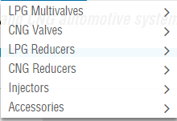

**FEATURES:**

1. CUSTOMER LOGIN SYSTEM
2. CHECK OUT SYSTEM
3. ORDER TRAKING SYSTEM
4. REGISTRATION OF CUSTOMERS
5. PRODUCT SUPPORT MESSAGE
6. CUSTOMER CARE TO LIKE FAQ QUESTIONN TO KEEP THEM AWARE OF WHAT PROBLEM THEY MIGHT BE FACING.
7. NEWS SERVICE ABOUT EXIBITION AND EVENTS AND ALSO NEWS ABOUT NEW PRODUCTS IN MARKET.
8. COMPANY INFORMATION TO MAKE THE CUSTOMER SATISFIED.

**INTERFACES:**

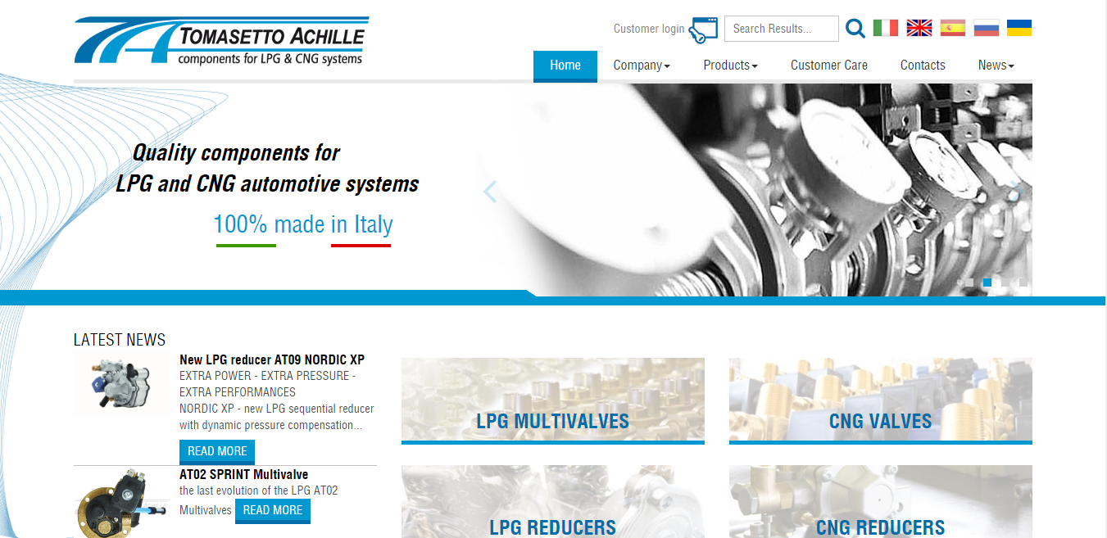

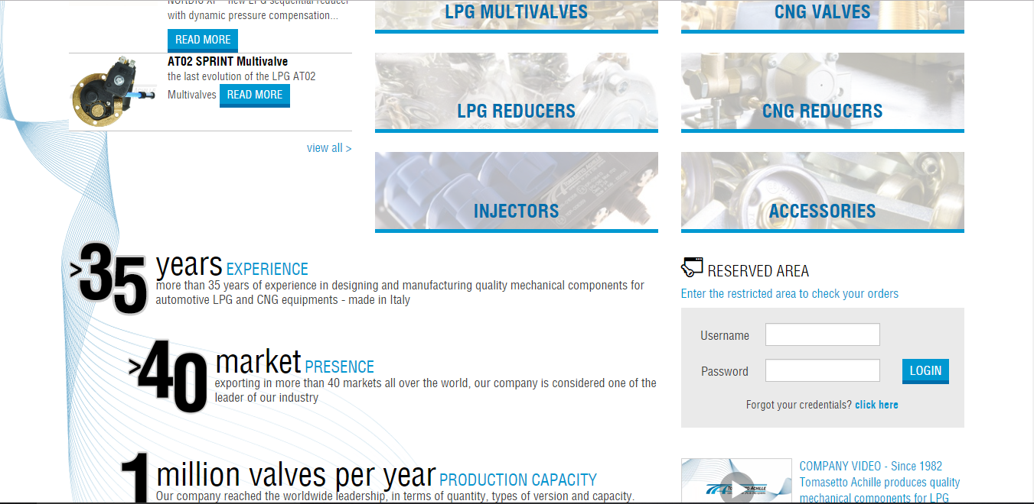

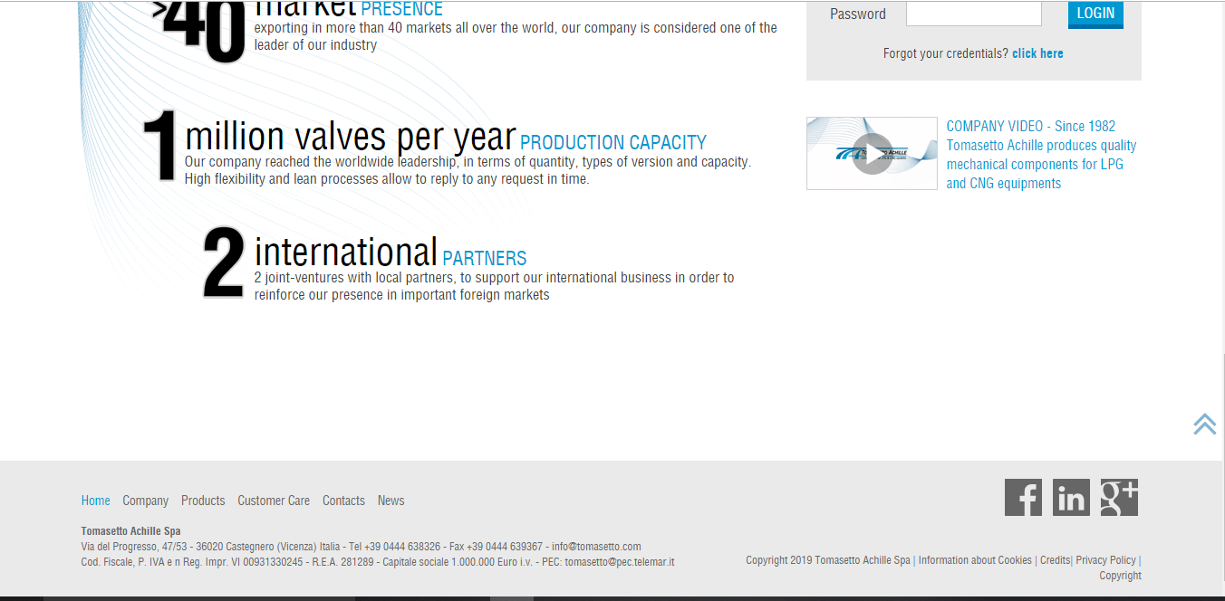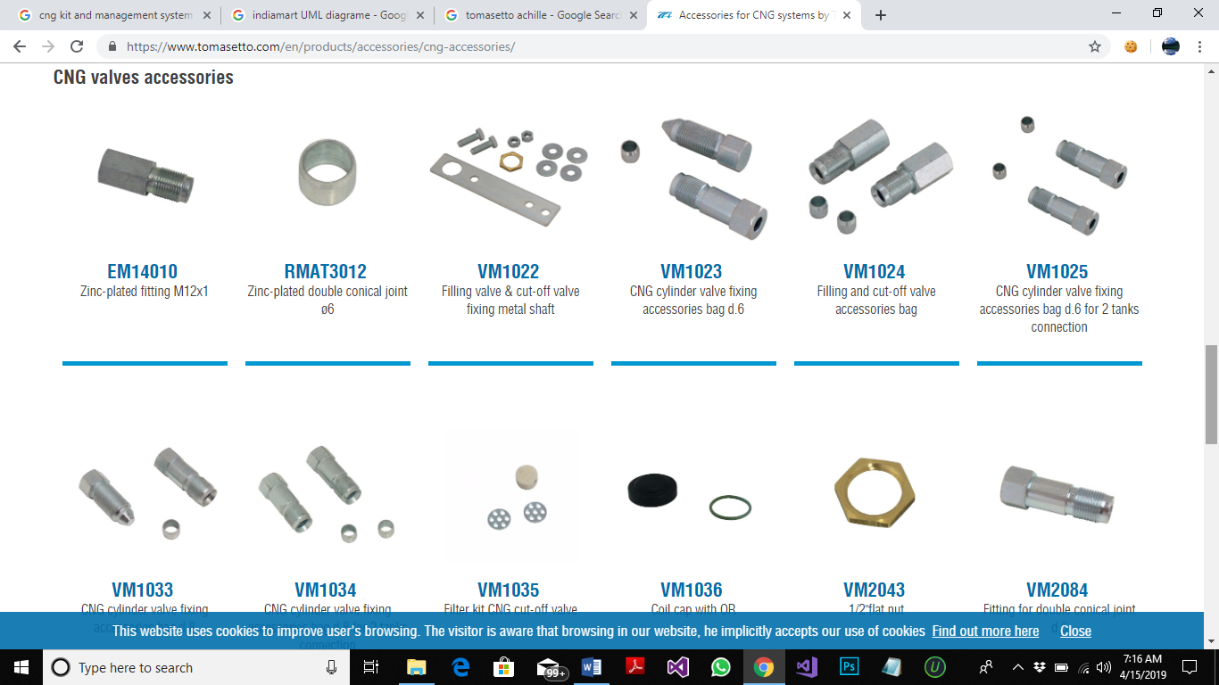

**COST:**

Not given

**DESIGN:**

DESIGN AND DEVELOPED BY **WEB AGENCY BY TELEMAR**